

**Pretty Paint- A Drawing app for kids**

Course: CSE 323

Section: 9

Group: 7

Group members:

|  |  |
| --- | --- |
| Ishrat Jahan Ananya | 1631636042 |
| Sarah Suad | 1632282642 |
| Nahian Noshin Nur | 1510798642 |

**Contents**

1. Introduction

a) Target audience and objective

b) Software Process Model

2. Project description

a) Features

b) Design Implementation and integration

c) Limitations and future scope

d) Job responsibility

**1. Introduction**

Pretty Paint is a fun and colourful android drawing app that allows many features for flourishing creativity.

**a) Target audience and objective**

It has been developed mainly with children in mind. The objective was to allow kids of age 3+ to express their creative self for mental growth. The colourful visuals and simple user interface easily grabs attention in a phone or better yet, a tablet.

**b) Software process model**

From designing to implementing and to the final product, the software process model we used is ‘The waterfall Model’.

It is the simplest and classic model available. It’s a step by step model where each step depends on the step that precedes it.

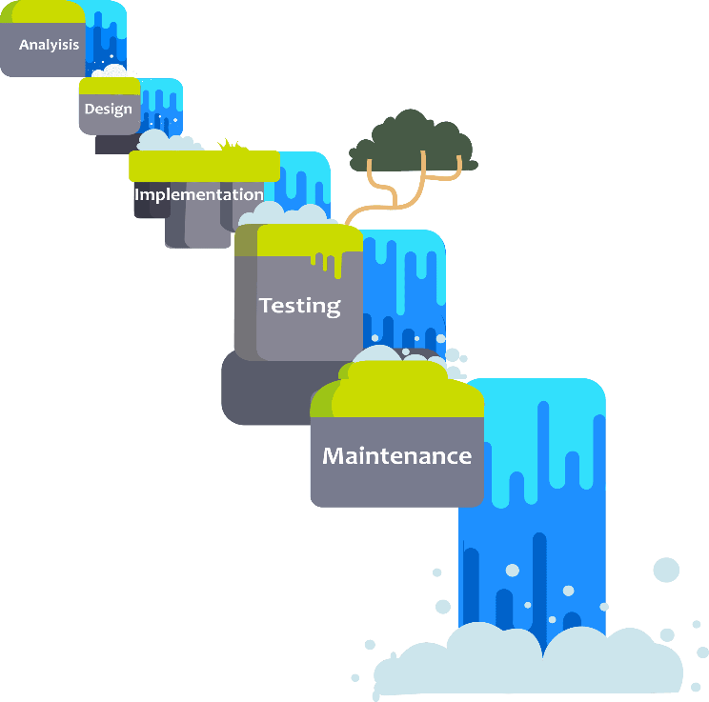

Fig 1: waterfall model

**2. Project Description**

**a) Features**

Some of the main features of the app are as follows:

* Free hand drawing
* Setting width of the brush
* Setting colour of brush from colour wheel
* Saving art
* Erase option

The following are a few screenshots to demonstrate the visuals of the app.

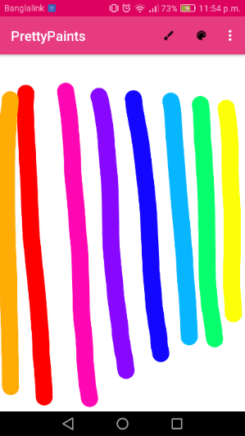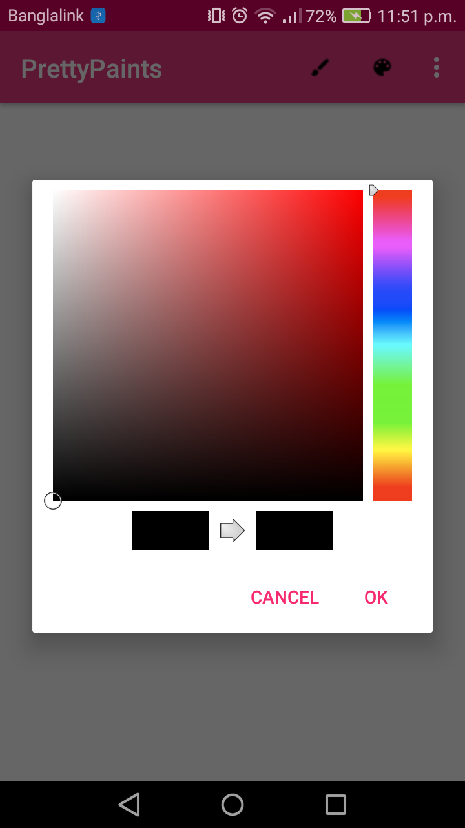

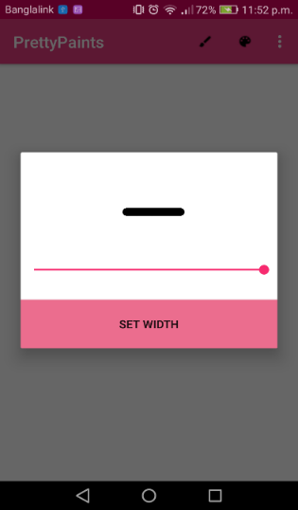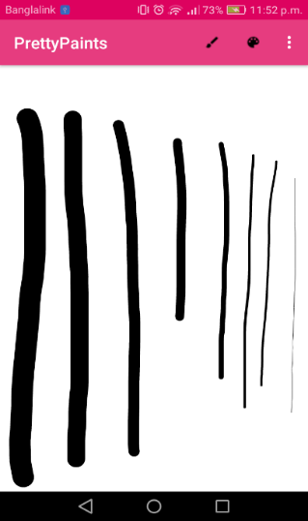

**b) Design implementation and integration**

Pretty Paints has been developed in Android Studio. We also used firebase as our external storage and minSDK version16.

Some of the classes or libraries used for the project are Paint, Bitmap, Hashmap, canvas etc. The design class diagram is as follows:

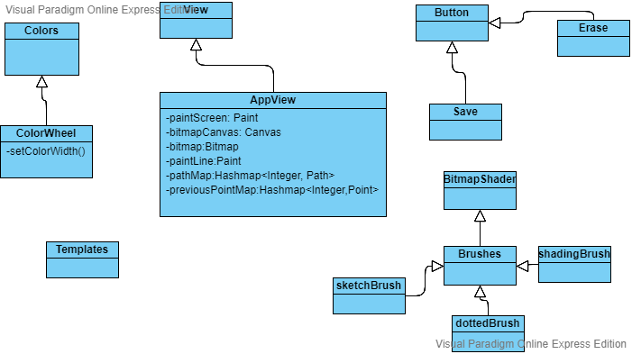

The integration of our project can be broken down into 8 smaller modules which are listed below:

**Module 1:**

* Creating basic UI layout
* Setting up Canvas

**Module 2:**

* Implementing touch recognition on Canvas and retrieving value of position on Canvas

**Module 3:**

* Incorporating stroke feature for drawing
* Incorporating erase feature

**Module 4:**

* Adding a ‘change brush size’ feature using a seekbar
* Drawing strokes with different widths onto Canvas

**Module 5:**

* Adding color picker feature
* Creating custom dialog to view chosen color and color width

**Module 6:**

* Adding ‘Save Image’ feature
* Allowing users to type text onto Canvas

**Module 7:**

* Creating custom brushes for users to draw with

**Module 8:**

* Allowing users to load photos from gallery to draw on
* Allowing users to choose from a library of templates to draw on

**c) Limitations and future scope**

Due to time constraint many features weren’t implemented such as module 7 and 8. There are still room for development in the future prospect.

**d) Job responsibility**

Below is a visual representation of our work plan expanded throughout the semester.

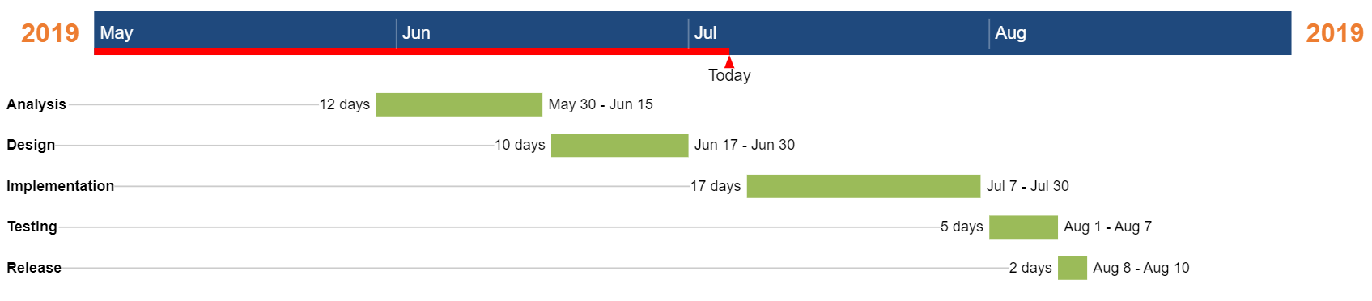

To finish the project, meetings at relevant times were held and each phase of the project was discussed. Each member was then tasked to finish their respective parts in time and later it was all brought together by Sarah while the report and presentation was handled by Ishrat and Nahian respectively.